http://www.oftwominds.com/blogmay13/EricA-pt1-5-13.html

A Brief History of Cycles and Time, Part 1 (guest essay)
(May 13, 2013)
"If I’ve learned one thing over the last 12 years from following markets, economics, and geopolitics is this: no man can push the Wheels of History. It unfolds in its own time and no other."
I am honored to publish a deeply insightful two-part essay by longtime contributor Eric A. on long-term cycles, and how they shape our spectrum of responses in periods of crisis and transformation. This essay has profound implications for our individual choices in the years ahead, and I believe it helps explain my own political/ financial philosophy outlined in my books:
Why Things Are Falling Apart and What We Can Do About It
Resistance, Revolution, Liberation: A Model for Positive Change
An Unconventional Guide to Investing in Troubled Times
Survival+: Structuring Prosperity for Yourself and the Nation
Here is Part 1 of Eric's essay. Part 2 will be published tomorrow.

Many of you may be familiar with the Foundation series by Issac Asimov. In it, mathematician "Hari Seldon spent his life developing a branch of mathematics known as psychohistor. Using the laws of mass action, it can predict the future, but only on a large scale; it is error-prone on a small scale."
In practice, we can see that this would be theoretically correct: we study history precisely because human nature is relatively the same and the same events recur with the same predictable responses. If history really were chaos--a muddle of events appearing randomly and being resolved in unpredictable ways--there would be no point in studying it.
Using this same method, in “Foundation” Hari Seldon uses his model to predict with great accuracy the unfolding of the human universe hundreds and thousands of years in the future.
But that’s sci-fi, right?
Not exactly. Like many sci-fi stories, “Foundation” takes a true premise and extrapolates it into the future. In the 30’s “Buck Rogers” hypothesized the existence of rockets and trips to Mars.Star Trek hypothesized the wide use of lasers--a laboratory curiosity--and phasers, similar to the microwave technology we use every day. Science Fiction by definition thinks ahead to ask “what if?” We know what is possible, but what if we could harness, refine, perfect it? By definition, it must be ahead of its time, or it wouldn’t be “Sci-Fi” but “Contemporary Fiction.”
Foundation originally appeared in Astounding Magazine in 1942. So how are we doing?
As it turns out, pretty good. There is a “Hari” working on exactly this problem: Harry Dent, of demographics research. “Demographics are destiny” he would say. As each generation is born, it demands support in housing and schools, then is productive in their middle years, creating the most wealth right on cue in their 50’s, then retiring and drawing resources until death, and so on through time. It cannot be changed except with mass epidemic or calamity of war. And this is provably true: demographics of the Boomers in the U.S. are measurably slowing the economy as they retire, precisely the way that Japan’s earlier baby boom slowed their economy into a Depression 20 years earlier.
There is Robert Prechter’s “Socionomics” study, which states that markets and governments don’t create human moves, but are instead the consequence of them. That is to say, human emotions and behavior run in cycles of set period. Obviously humankind cannot become infinitely more optimistic forever into the future. In the same way trees don’t grow to the sky, at some point human expectation must reverse and become less optimistic, more conservative and pessimistic until it reaches an opposite extreme.
And this theory has a lot going for it: if governments truly controlled stock markets, economies, nations, then why would they ever decline? No government or market would ever voluntarily get smaller, less powerful, and prosperous. And yet despite everything they can do to prevent them, markets and economies always, always DO reverse. Always. And what’s more, they move in predictable cycles over time, from the 4-year business cycle to the 70-odd year Kondratieff Cycle.
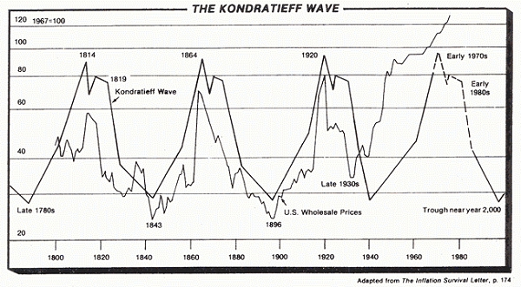
This 70-year cycle of human lifetime is what Strauss and Howe refine in their work The 4th Turning. The idea that there are four generations that proceed in predictable order: Prophet, Hero, Nomad, Artist that occur over and over again in western history since at least the 16th century. Imagine a kitten being born, living half its life in winter, never seeing spring until they are full-grown—how that affects their behavior, their perception of life.
This is the same for the generations, being born in turns in a stable, expanding world or an unstable, contracting one markedly alters the perception and behavior, the demands outlook, and skills of a 20-year generation. This not only meshes with the Kondratieff Cycle but explains the expansions and contractions, breathing in and breathing out, the ebb and flow of optimism and pessimism that are easily so predictable in aggregate, just as Asimov predicted.
There is one additional candidate: market timer Martin Armstrong. Armstrong doesn’t just follow cycles, but like Hari Seldon, has made a complex computer model of all factors, and has made a career predicting precise turns in timing, often to the day, as in the market crash of 1987.
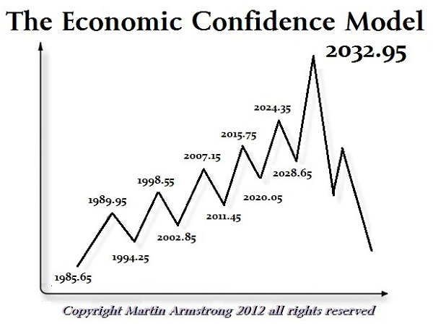
How can he do this? Because people in aggregate do not have as much free will as they believe they do. We as people are not only our own observations and desires, but we exist as an integral part of a larger ecosystem – a social, economic, political, thermodynamic, and mathematical ecosystem that we cannot escape. Just as the kitten above, living in a world that has always been snow leads you to simply BE different than who you might have been only knowing the ease of the summer sun.
What could possibly create human cycles with such predictability in time and frequency? Although everyone from Ecclesiastes to Machiavelli to Munehisa Homma remarks that they exist, no one really knows. But how about something like this?
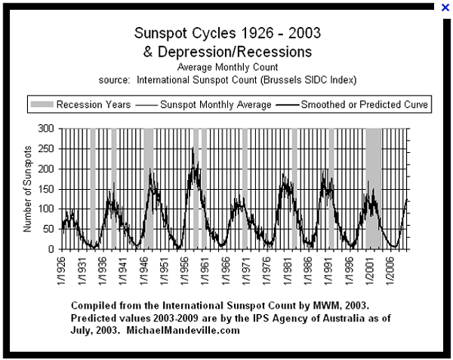
Or other, longer cycles, from the sun, the stars, the weather, the planets? We don’t know. Like gravity or time, we can only see and measure the effects, we cannot yet hypothesize their cause.
Back to charts, many of you may be familiar with this chart by market commentator Karl Denninger, from 2009:
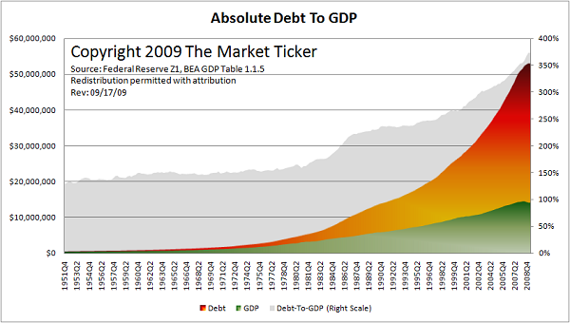
What does this tell us? GDP, the real economy theoretically rises by let’s say 3% a year. However since 1971, debt has risen something more like 9% a year. Any 5th grade student recognizes the law of simple exponents. That GDP, that is, economic “Reality” is falling ever further behind economic fantasy, that is, all the undelivered paper promises represented by “debt.”
This is the mathematical system we live in that also largely represents the thermodynamic reality of the U.S., and critics have been bringing this to public attention since the budget debates of the ‘80’s. The injustice, the irrefutability, and impossibility of avoiding the sudden collapse of the market--indeed the real world of politics, war, death, and human action—back to the lower line. They have been warning the public since before the first crash of 2001 that this MUST happen, and must happen badly.
So why hasn’t it crashed? Why, 14, 24, 34 years later is the economy still limping along, the illusions still firmly in place despite every evidence and warning?
It isn’t time.
We in the blogosphere have been warning people about impending collapse for over a decade, and for the most part we’ve been right: tech on the Nasdaq crashed from 5000 to 1000, never to recover. Housing crashed never to recover. The Dow fell from 14,000 to 6,600. Every bank nationally and worldwide is insolvent. Most developed nations are also insolvent along with their debt, which is the de facto currency and blood of the very system of human exchange. We predicted this and were correct.
Yet seen another way, nothing has changed. Instead of falling to 7 PE and 4% dividend ratio, the Dow rebounded to 14,700. Instead of over-correcting beyond a 3:1 income ratio, below $126,000, U.S. housing remains levitated at roughly $200,000, far above what the young can afford, stranding 20M houses in vacancy and decay. With market proof, mathematical proof, proof of financial action such as the hundred Trillion in bank bailouts and the political red flag of the Cyprus bail-in, how can this be?
It isn’t time.
If I’ve learned one thing over the last 12 years from following markets, economics, and geopolitics is this: no man can push the Wheels of History. It unfolds in its own time and no other.
Look at the Generations: at this time, the Boomers are still in undisputed control of the US, economically, socially, and politically. They own a quorum of all wealth.
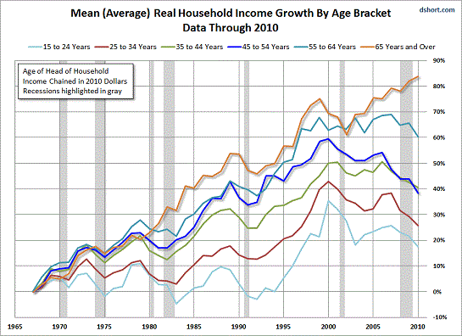
They have a supermajority in Congress. Economically, attention is largely focused on only this demographic which still has some remaining money—the Viagra and prescription drug ads, the focus on investing and retirement, even the age of the actors in movies, TV, and commercials tells us so. The young, although now larger in numbers, have no effective political power. This will change, but it only changes when it does, on the strict schedule of demographics.
Socially, we saw the markets crash into ’01 and ’08. But like the matching dates of 1921 and 1929 these were sudden extremes in human pessimism which could not be sustained. It matters not at all whether they are “true,” or whether fundamentals support them: human emotion cannot remain at extremes of either optimism or pessimism; it cannot move in one direction all at once. They must and will fluctuate, and the time it takes for the mood of an aggregate population to fluctuate is a predictable quantity, at minimum the 4-year business cycle.
Speaking of 1929, the inflation-adjusted Dow:
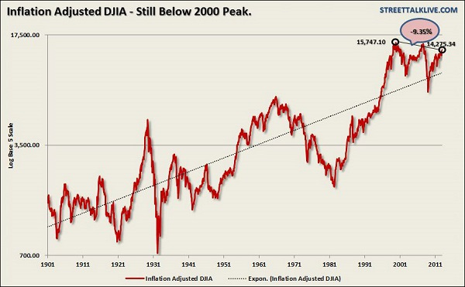
Or as inflation is notoriously difficult to measure, you may prefer the in vs out flows to gold as a money-standard:
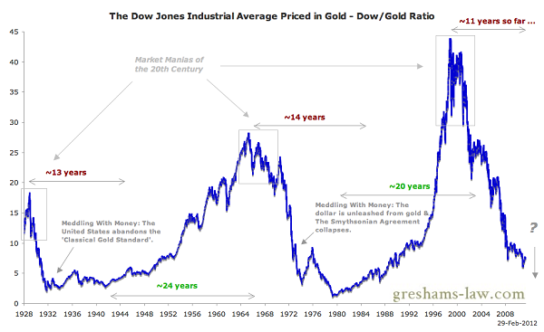
Although noisy, note one thing in both these charts: the highs and lows tend to occur with a set frequency. The Dow with a small frequency of 4 years, a larger of 8, then 40, and so on, giving us times of 1929, 1968, and 2008. In Dow:Gold ratio, we have something only slightly more complicated, neatly marked by Greshams-law.com: 14 year Bear markets, followed 20 year Bull markets. There are very few ultra-long historical charts, but here is one:
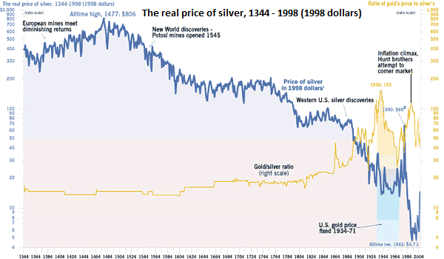
For context, in 1344 A.D., gunpowder was a new invention, The 100 Years War was beginning, Joan of Arc hadn’t been born, and America wouldn’t be discovered for another 150 years.
Yet note the chart above shows the same similar periods of highs and lows, for both 8 and 40 years. Why?
Hari Seldon’s phychohistory. The waves of human emotion, of optimism and pessimism both long and short term haven’t changed. Short-term it can only persist for 4 years while longer term only for sub-40 years, or exactly one-half one generation. Divide your four 20-year generations in half and you’ll find that same turning.
So why are the markets still going up? Why can’t people respond to warnings of the blogosphere, or warnings of collapsing economies and accounts right before their eyes?
Answer: Because they can’t. It isn’t time.
by Eric A.
Part 2 will be published tomorrow.

http://www.oftwominds.com/blogmay13/EricA-pt2-5-13.html

A Brief History of Cycles and Time, Part 2 (guest essay)
(May 14, 2013)
Part 2 of the guest essay by Eric A.: "Because it's time."
I am honored to publish a deeply insightful two-part essay by longtime contributor Eric A. on long-term cycles, and how they shape our spectrum of responses in periods of crisis and transformation. This essay has profound implications for our individual choices in the years ahead, and I believe it helps explain my own political/ financial philosophy outlined in my books:
Why Things Are Falling Apart and What We Can Do About It
Resistance, Revolution, Liberation: A Model for Positive Change
An Unconventional Guide to Investing in Troubled Times
Survival+: Structuring Prosperity for Yourself and the Nation
Here is Part 2 of Eric's essay.

Let me ask you something: Do you really think your ancestors didn’t see the Depression coming in 1921 or in 1929? Of course they did. The Balloon Option-ARM mortgage had just been invented, creating a housing boom larger and even more groundless as our own, immortalized by the Marx Brothers in The Cocoanuts. They warned the world then just as we do now, and no one listened then, just as they don’t now. Why? It wasn’t time.
Likewise, do you think Hoover and Roosevelt didn’t do everything they could, whether legal or illegal to stop the endless economic decline after 1929? Of course they did. Roosevelt confiscated the entire money supply, packed the Supreme Court, and took control of the entire US economy to no avail. Henry Morgenthau, Roosevelt’s Treasury Secretary, admitted,
"We have tried spending money. We are spending more than we have ever spent before and it does not work... We have never made good on our promises. I say after eight years of this Administration we have just as much unemployment as when we started. And an enormous debt to boot."
And the media failing to report? I’ll show you just three graphics:
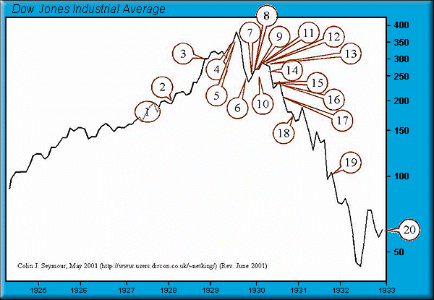
1. "We will not have any more crashes in our time." - John Maynard Keynes in 1927 (1)
2. "I cannot help but raise a dissenting voice to statements that we are living in a fool’s paradise, and that prosperity in this country must necessarily diminish and recede in the near future." - E. H. H. Simmons, President, New York Stock Exchange, January 12, 1928
"There will be no interruption of our permanent prosperity." - Myron E. Forbes, President, Pierce Arrow Motor Car Co., January 12, 1928 (2)
3. "No Congress of the United States ever assembled, on surveying the state of the Union, has met with a more pleasing prospect than that which appears at the present time. In the domestic field there is tranquility and contentment...and the highest record of years of prosperity. In the foreign field there is peace, the goodwill which comes from mutual understanding." - Calvin Coolidge December 4, 1928 (3)
4. "There may be a recession in stock prices, but not anything in the nature of a crash." - Irving Fisher, leading U.S. economist , New York Times, Sept. 5, 1929 (4)
5. "Stock prices have reached what looks like a permanently high plateau. I do not feel there will be soon if ever a 50 or 60 point break from present levels, such as (bears) have predicted. I expect to see the stock market a good deal higher within a few months." - Irving Fisher, Ph.D. in economics, Oct. 17, 1929
"This crash is not going to have much effect on business." - Arthur Reynolds, Chairman of Continental Illinois Bank of Chicago, October 24, 1929
"There will be no repetition of the break of yesterday... I have no fear of another comparable decline." - Arthur W. Loasby (President of the Equitable Trust Company), quoted in NYT, Friday, October 25, 1929
"We feel that fundamentally Wall Street is sound, and that for people who can afford to pay for them outright, good stocks are cheap at these prices." - Goodbody and Company market-letter quoted in The New York Times, Friday, October 25, 1929 (5)
6. "This is the time to buy stocks. This is the time to recall the words of the late J. P. Morgan... that any man who is bearish on America will go broke. Within a few days there is likely to be a bear panic rather than a bull panic. Many of the low prices as a result of this hysterical selling are not likely to be reached again in many years." - R. W. McNeel, market analyst, as quoted in the New York Herald Tribune, October 30, 1929
"Buying of sound, seasoned issues now will not be regretted." - E. A. Pearce market letter quoted in the New York Herald Tribune, October 30, 1929
"Some pretty intelligent people are now buying stocks... Unless we are to have a panic — which no one seriously believes, stocks have hit bottom." - R. W. McNeal, financial analyst in October 1929 (6)
7. "The decline is in paper values, not in tangible goods and services... America is now in the eighth year of prosperity as commercially defined. The former great periods of prosperity in America averaged eleven years. On this basis we now have three more years to go before the tailspin." - Stuart Chase (American economist and author), NY Herald Tribune, November 1, 1929
"Hysteria has now disappeared from Wall Street.” - The Times of London, November 2, 1929
"The Wall Street crash doesn’t mean that there will be any general or serious business depression... For six years American business has been diverting a substantial part of its attention, its energies and its resources on the speculative game... Now that irrelevant, alien and hazardous adventure is over. Business has come home again, back to its job, providentially unscathed, sound in wind and limb, financially stronger than ever before." - Business Week, November 2, 1929
"...despite its severity, we believe that the slump in stock prices will prove an intermediate movement and not the precursor of a business depression such as would entail prolonged further liquidation..." - Harvard Economic Society (HES), November 2, 1929 (7)
8. "...a serious depression seems improbable; [we expect] recovery of business next spring, with further improvement in the fall."- HES, November 10, 1929
"The end of the decline of the Stock Market will probably not be long, only a few more days at most." - Irving Fisher, Professor of Economics at Yale University, November 14, 1929
"In most of the cities and towns of this country, this Wall Street panic will have no effect." - Paul Block (President of the Block newspaper chain), editorial, November 15, 1929
"Financial storm definitely passed." - Bernard Baruch, cablegram to Winston Churchill, November 15, 1929 (8)
9. "I see nothing in the present situation that is either menacing or warrants pessimism... I have every confidence that there will be a revival of activity in the spring, and that during this coming year the country will make steady progress." - Andrew W. Mellon, U.S. Secretary of the Treasury December 31, 1929
"I am convinced that through these measures we have reestablished confidence." - Herbert Hoover, December 1929
"[1930 will be] a splendid employment year." - U.S. Dept. of Labor, New Year’s Forecast, December 1929 (9)
10. “For the immediate future, at least, the outlook (stocks) is bright.” - Irving Fisher, Ph.D. in Economics, in early 1930 (10)
11. "...there are indications that the severest phase of the recession is over..." - Harvard Economic Society (HES) Jan 18, 1930 (11)
12. "There is nothing in the situation to be disturbed about." - Secretary of the Treasury Andrew Mellon, Feb 1930 (12)
13. "The spring of 1930 marks the end of a period of grave concern... American business is steadily coming back to a normal level of prosperity." - Julius Barnes, head of Hoover’s National Business Survey Conference, Mar 16, 1930
"...the outlook continues favorable..." - HES Mar 29, 1930 (13)
14. "...the outlook is favorable..." - HES Apr 19, 1930 (14)
15. "While the crash only took place six months ago, I am convinced we have now passed through the worst — and with continued unity of effort we shall rapidly recover. There has been no significant bank or industrial failure. That danger, too, is safely behind us." - Herbert Hoover, President of the United States, May 1, 1930
"...by May or June the spring recovery forecast in our letters of last December and November should clearly be apparent..." - HES May 17, 1930
"Gentleman, you have come sixty days too late. The depression is over." - Herbert Hoover, responding to a delegation requesting a public works program to help speed the recovery, June 1930 (15)
16. "...irregular and conflicting movements of business should soon give way to a sustained recovery..." - HES June 28, 1930 (16)
17. "...the present depression has about spent its force..." - HES, Aug 30, 1930 (17)
18. "We are now near the end of the declining phase of the depression." - HES Nov 15, 1930 (18)
19. “Stabilization at [present] levels is clearly possible.” - HES Oct 31, 1931 (19)
20. "All safe deposit boxes in banks or financial institutions have been sealed... and may only be opened in the presence of an agent of the I.R.S." - President F.D. Roosevelt, 1933 (20)
Source: Colin J. Seymour, June 2001
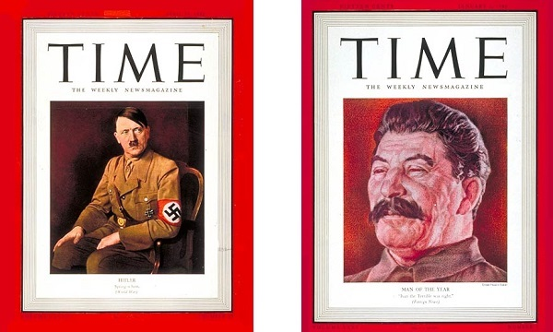
Man of the Year, 1938 Man of the Year, 1939
Poor enough reporting for ya? I’m sure you’d find the same reporting in the Great Depressions of 1837 and 1870, while many of you personally remember the W.I.N. buttons and pro-American quotes in the Depression of 1968-1979.
History never changes. Or, at least it changes very slowly indeed.
So here we are, like those before us, warning of our own Great Depression, of our own World War, or of even larger cycles like the fall of the English, Spanish, or Roman empires. And so far as we can tell, few listen and nothing changes. Why?
Because it isn’t time.
You think they didn’t see the rise of Fascism and WWII in the 30’s? What was the Lincoln Brigade about? You think the people of 1930 didn’t also inform each other, stall and delay the day of reckoning, and struggle to prepare? Of course they did. Just as much as we ourselves and our present government have. The delay due to their ability and willingness to intervene is already factored into the cycle.
So why didn’t war break out in 1932, 1936, or for the U.S., in 1940? It wasn’t as if people didn’t see it coming, just as we see our own war and challenges now.
Because it wasn’t time. What I mean by that is, no matter how far seeing, History, as Hari Seldon would say, is made up of the aggregate, not the individual. No individual-- not even Churchill chafing under Chamberlain in 1938—could change it.
It only happens slowly, when one by one the great mass of the population have changed their minds and their behavior. Only then can history unfold. You, me, even Barack Obama, Ben Bernanke, or George Soros cannot push the great Wheel of History around because it is made of all 6 Billion of us, the whole planet, the whole market, and the sum of human understanding.
To me, this the cardinal sin of the blogosphere, or indeed of the times: that we know what is best for everyone, as writers, pundits, politicians. That we need to make the other guy "wake up." We need to make them see as we do, act as ourselves, obey our will. Isn’t this the very defect we attribute to our enemies? That they’re always galumping around telling everybody what to do and how to live?
"They"—your family, your neighbors, your country--need to wake up? Let me ask you: "How did YOU wake up?" I can answer that without knowing you: a little at first, then all at once, in your own time. Neither is the journey for any of our "waking up" complete.
Telling people what is going on is one thing, it’s free speech, expressing our opinions on where we are and how the world works. Forcing others to believe something, become something, act in a way we believe they should is the first step to violence. If you believe in and value Liberty and the free exchange of ideas as I do, don’t do it. Changing the other guy is not your job.
Given that we can’t change history, and it’s reprehensible to force yourself on others, one might ask what good is it to talk about it? Screw the other guy if he won’t learn. Ride the stock market up for every dollar. "Eat, Drink, and be Merry, for tomorrow we die."To which I would respond as Dorothy Parker, "But alas, we never do." We may not be able to change the world or the course of history, but we can prepare on our own, individual level. And that’s the key, the individual level.
Markets, governments, wars, they are aggregations that will only change on schedule after some series of remarkable events forces them to respond and adjust.
This is part of Charles Hugh Smith’s discussions of fiefdoms, feedback, and the status quo: by definition the status quo can’t change, because if it could it wouldn’t be a status quo mired in internecine wrangling; it would be smoothly evolving into a new stable system. The system as we know it can’t change, but YOU can.
And as this is the only effort that’s going to effect any change in your life vs. the tide of history, it’s also the only one you have control over and the only one that’s going to do you any good.Dmitry Orlov has mentioned this many times regarding the collapse of governments and empires, in his case, the Soviet Union.
Did the U.S.S.R. disappear overnight? No. It took time, the exact amount of time for people to recognize, test, explore, and adjust their behavior. For some slower, and others more quickly. That is to say it took years, each piece unfolding one person at a time, one personal realization and event at a time in their own order. Once the nation collapsed, did it suddenly reform into the functional and rising state Russia enjoys now?
No. Again, it took time, decades of unfolding from 1991 until 2013, another whole generation, one "turning." Not until those who carried the template of the old ways passed away and new, younger people with new thinking replaced them. Not one of them could have stopped it or hurried it along although many tried, no different than any other time in history. As for the other guy, it’s always been clear that we’re all in this together. If your neighbors have a problem, then you have a problem whether down the street or in the world. This is why we all help each other best we can according to our abilities, in our own time.
What we as bloggers and far-seers have been trying to do is to change the aggregate, which cannot be done. The aggregate WILL change, but it can only change in its own schedule. We can continue to tell the truth, but after decades of status quo, we should not expect our words to change the world, our nation, or to some extent even our community. The only thing we can realistically change is ourselves with our own actions, and that is where all real change comes from, one person: one action at a time. 6 billion tiny events, tiny tipping points, changing minds who realize themselves one by one.
So what revolutionary act can you make today? If you read OfTwoMinds.com, PeakProsperity.com or similar sites, you already know the direction of history and what may be needed by you and the nation in the years ahead. What can you do to fill those gaps and prepare in your own life? Because the Wheels of History, although grinding exceeding slow, do get there in the end, made up of the decisions of billions of human actors. You may not be able to change your nation or the desperate situation we find ourselves in, but each of you can change yourself. You can make your own lifeboat in the midst of our own national challenge or "collapse." Only through that individual preparation could we find a million safety nets which prevent collapse.
And if that is all that’s asked of you, it’s good, for that’s all that’s possible.
Start today. It’s time.
by Eric A.

Thank you, Eric, for sharing your analysis and conclusion. Understanding is waking up.

